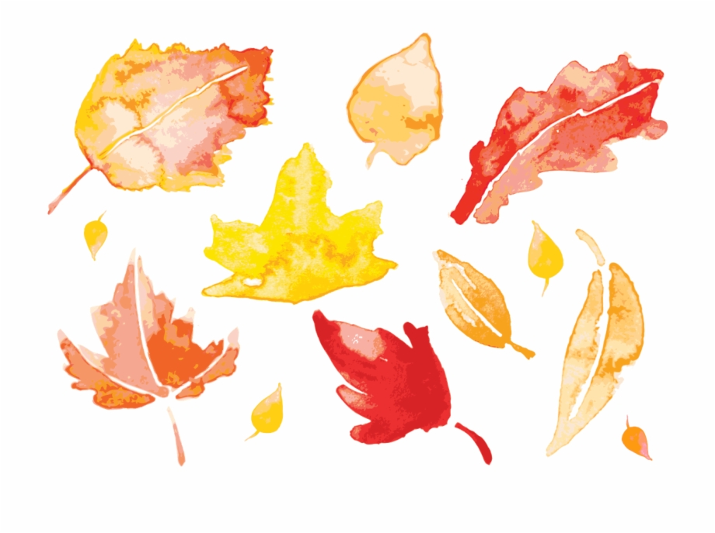

Dear parents,

I hope you had a restful and relaxing weekend. I also hope that you are reading to your child at least 3 times weekly and having your child color in their November Reading Calendar for the days that you read. Happy reading!!

This week’s work is as follows.

Ragia Elkhashab.

Regards,

Ragia Elkhashab.

Ragia Elkhashab

Newsletter 12 week 13

November 23rd - November 27th

Important notes

We will be having our Thanksgiving dish party on Wednesday.

Thursday is a day off.

Starting this week, we will be sending a book from the library weekly. All you need to do is to read the book to your child or even look through the book together and discuss the pictures.

If you haven’t send a long sleeves T-shirt to be kept in class please send it ASAP as the weather is getting colder.

Reminder

-We will send one sheet for Homework every Thursday. The Homework due back every Sunday.

-Please keep the classwork sheets that we send on Thursdays at home and send back the empty file on Sundays.

-P. E is on Tuesdays. Please make sure that your child comes to school wearing his/her P.E uniform.

- Kindly visit: [www.relkhashab.weebly.com](http://www.relkhashab.weebly.com) for weekly updates.

English:

This week we will introduce letter Ll sound and vocabulary(lollipop-leg-lip-lamb-lion-ladybug-lamb-lemon-lunchbox).

We will also review (Aa-Kk) sounds and vocabulary.

-Identifying beginning sound.

- Clapping out syllables in words.

Maths:

We will review numbers from 1to 9 for recognition and formation.

Introduce number 10 recognition and formation.

New concept: more, fewer, same.

Science:

We will be discussing the weather (sunny-rainy-windy-cloudy)

Social Studies:

Thanksgiving.

